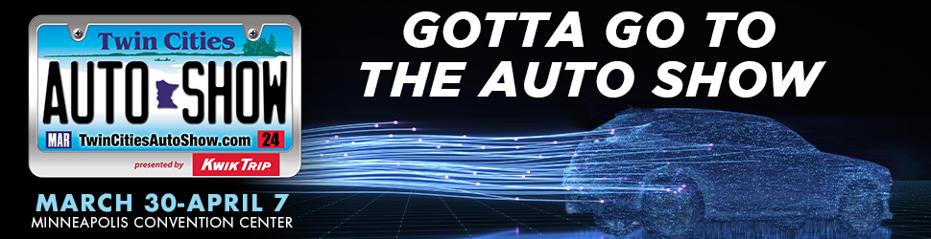

51st ANNUAL TWIN CITIES AUTO SHOW
Presented by Kwik Trip

March 30 – April 7, 2024 at the Minneapolis Convention Center

Minneapolis (Updated as of March 28, 2024) --- The 51st Annual Twin Cities Auto Show presented by Kwik Trip will roll into the Minneapolis Convention Center for nine days, March 30 – April 7, 2024. The event, the largest consumer show in the Upper Midwest, is produced by the Greater
Metropolitan Automobile Association of Minnesota, Inc. (GMADA).

The Twin Cities Auto Show is the place to compare hundreds of new vehicles in every category - sedans, compacts, SUVs, trucks, EVs, luxury cars - from domestic and imported brands all under one roof without driving to dealerships around town, including new makes and models that can’t be found on dealer lots. The Twin Cities Auto Show is a non-selling show.

What’s New in 2024:

- Celebrity Appearance: Meet Constance Nunes of Netflix’s “Car Masters: Rust to Riches” Saturday, March 30 (11 a.m. and 2 p.m.) and Sunday, March 31 (12 p.m. and 3 p.m.)
in the Custom Garage

Constance Nunes – “A Glam Girl Wrenching in a Boy’s World” - has over 19 years of experience in the automotive industry. She is the CEO and lead mechanic, designer, and builder at CARS By Constance in Southern California.

Constance stars as the lead mechanic on the Netflix original series, “Car Master: Rust to Riches,” where she has helped the team at Gotham Garage build unique specialty cars for five seasons with a sixth currently in production.

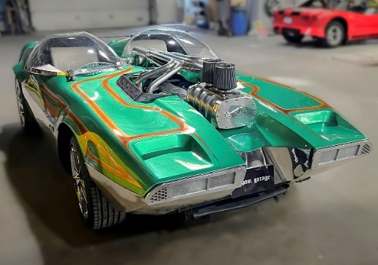
The Twin Cities Auto Show is thrilled to welcome one of the more famous cars built at Gotham Garage during the filming of “Car Master: Rust to Riches” – The Splittin’ Image, designed by Ire Gilford, is a life-size working car modeled after a Hot Wheels toy.

This custom Splittin’ Image is built on a 1986 Corvette with the original engine and transmission. It was built and customized in 2015 by Gotham Garage owner Mark Towle with Constance as the lead engine mechanic on the project.

--- more ---

Page 2
2024 Twin Cities Auto Show

- Cars Against Crime™ Display of Movie and TV Cars

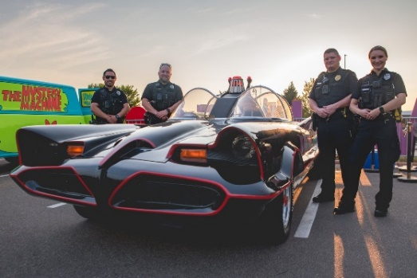
Cars Against Crime™ is a nonprofit that raises funds to provide grants to service organizations benefitting police, fire fighters, and first responders.

Cars Against Crime utilizes a world class collection of movie cars and television cars. These crime fighting vehicles serve as tools to enhance events, create memories, and bring joy to the community.

Organizations supported in 2024 include Wills for Heroes, Metro Critical Incident Stress Management, Crimestoppers, and Frontline Foundation.

The Twin Cities Auto Show is hosting this fantastic display to encourage donations to Cars Against Crime in support of our brave public safety professionals.

For more information or to make a donation, please visit carsagainstcrime.org.

- Adrenaline Avenue

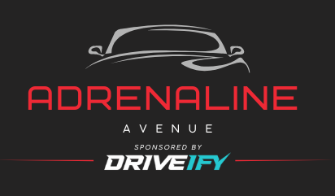
Introducing Adrenaline Avenue presented by DRIVEIFY.

This display is your license to dream, your invitation to step into the driver’s seat and feel luxury at its finest.

Immerse yourself in the power, style, and exhilaration that define some of the world’s most coveted vehicles.

- Get Your Auto Show Tickets at Kwik Trip

Kwik Trip will sell Twin Cities Auto Show tickets at select stores around the Twin Cities.

Tickets sold at Kwik Trip stores will be $6 off the at-the-door price of $17. Kwik Rewards members may have the chance for additional perks.

Plus, attendees will be able to register onsite every day of the show to win FREE fuel for a year, compliments of Kwik Trip. No purchase necessary.

--- more ---

Page 3
Twin Cities Auto Show

Show Highlights

- Twice as big as years past, the 2024 Electric Vehicle Neighborhood and the Electric Garage powered by Xcel Energy will be charged up with experts, the latest in electric vehicle technology, and information to help potential EV buyers make their decision to
plug in.

The life-size Xcel Energy Garage allows you to see how low-impact and convenient electric vehicle ownership can be, especially when you can charge your vehicle right in your own garage. We look forward to sharing this demonstration with attendees and helping them make an informed decision about electric mobility.

Sign up to test drive one or more EVs in which a professional driver will acquaint attendees with the vehicle and ride along on your test drive. Routes have been pre-determined to make it a convenient and comfortable experience. Manufacturers offering test drives include Ford (Mustang and Lightning), Hyundai, Mercedes-Benz, Mitsubishi, Nissan, and Polestar.

Attendees can also register to win a fresh-and-foldable Honda Motocompacto, the new ultra-compact e-scooter which becomes its own lightweight, compact, and stackable carrying case.

Legendary Meteorologist Paul Douglas is back as the Electric Vehicle spokesperson for the Twin Cities Auto Show. An EV owner himself, Paul offers intelligent insight into the EV products available.

- The 2024 Car of the Show is the Honda Pilot. The Pilot is the largest and most powerful SUV in Honda history and will be on display at the show entrance, in the Convention Center concourse, and within the Honda display.

- Luxury Lane is bigger than ever this year! The display has established itself as a must-see for both automotive enthusiasts as well as casual car fans. Discover some of Minnesota’s finest and most lavish vehicles.

- Subaru will be hosting dog adoptions as a part of their Subaru Loves Pets Campaign.
The dogs will be from Midwest Animal Rescues and Services, a local organization
committed to the awareness and support of homeless dogs and cats.

- At the Custom Garage sponsored by Automotive Concepts, attendees can find ways to make cars as unique as possible. Whether they dream of sleek luxury, rugged off-road capability, or cutting-edge technology, we’re here to help customize new vehicles to perfectly suit any lifestyle.

- The Unique Classic Cars room is sponsored by Unique Classic Cars of Mankato. Step back in time and explore a fantastic collection of classic cars. Immerse into automotive history as attendees wander among meticulously restored vintage vehicles, each with its own story to tell.

- Minnesota State Patrol Troopers will be on hand to talk about their mission to keep people safe on the roads. The troopers will have some of their squad cars on view, including a 1954 Ford and 1979 Dodge St. Regis.

--- more ---

Page 4
2024 Twin Cities Auto Show

Special Events

Minnesota Broadcasters Association New Car & Truck Awards: Saturday, March 30

Join us at noon on Opening Day to learn which vehicles will be honored with an MBA’s New Car & Truck Award.

The 12 award categories include: Electric Vehicle, Hybrid Electric Vehicle, Subcompact & Compact Car, Midsize & Large Car, Luxury Car, Luxury SUV, Full Size Pick-up Truck, Compact/Mid-Size Pickup, Large SUV, Mid-Size SUV, Mini Van & Van, and Best in Show.

This event will be held in the Electric Vehicle Neighborhood and hosted by Paul Douglas.

Military Appreciation Night: Tuesday, April 2

On this 10th annual Military Appreciation Night, all active military and veterans will receive
FREE entry to the Twin Cities Auto Show courtesy of Toyota. Guests and family members accompanying military professionals will receive $7 off admission.

A ceremony will be held at 7 p.m., in the Toyota display, complete with color guard and the singing of “The National Anthem.” On behalf of the GMADA, the Twin Cities Auto Show will present donations to the Disabled American Veterans (DAV) of Minnesota and the Minnesota Assistance Council for Veterans (MAC-V).

Career in Cars Day: Wednesday, April 3 from 10 a.m. – 2 p.m.

The Minnesota Auto Dealers Association (MADA) is once again hosting a day dedicated to showcasing the careers available in the retail auto industry for young adults and job seekers. Anyone interested in attending can sign up on the Auto Show website.

Those who register in advance will receive a special credential, free admission to the Twin
Cities Auto Show, and a complimentary Auto Show t-shirt (while supplies last).

“Survivor” Casting Call: Thursday, April 4 from 4 – 9 p.m.

Join WCCO and the Twin Cities Auto Show for an open casting call. This is Minnesota’s chance to apply for the adventure of a lifetime.

Auto Show After Dark: Friday, April 5 beginning at 6 p.m.

On this evening, we turn down the show lights and illuminate the show floor with headlights, running lights, interior lights – all to produce a brilliant nighttime atmosphere.

--- more ---

Page 5
2024 Twin Cities Auto Show

The 51st Annual Twin Cities Auto Show

LOCATION: Minneapolis Convention Center
1301 Second Ave. South, Minneapolis

DATES: Saturday, March 30 through April 7, 2024

HOURS: Fridays, Saturdays, Wednesday, Thursday 10 a.m. – 9 p.m.
Monday and Tuesday 4 p.m. – 9 p.m.
Sunday 10 a.m. – 7 p.m.

TICKETS: Adults (16+) $13 online ($17 onsite)
Teens (11 – 15) $6
Children 10 and under FREE

Military Appreciation - Tuesday, April 2
FREE for Vets and Current Military
$7 off for Family and Friends

Half-Price Wednesday (April 3) $8.50
$3 off coupons are available at GMADA metro member auto dealerships.

WEBSITE: TwinCitiesAutoShow.com

SOCIAL: Facebook and Snapchat: TCAutoShow
Twitter, Instagram, and TikTok: @tcautoshow

PRODUCER: The Twin Cities Auto Show is a production of the Greater Metropolitan Automobile Dealers Association (GMADA). GMADA is an organization consisting of new car and truck franchised dealers in the Greater Minneapolis and St. Paul area.

The 2024 GMADA Chair is Tim Carter of Richfield Bloomington Honda. GMADA President is Scott Lambert. Twin Cities Auto Show Director is Mary Velline.

MEDIA NOTE

A media preview event will be held
on Saturday, March 30 from 8 – 10 a.m.
Please mark your calendar and plan to join us. Guests are welcome.
Contact Molly Steinke to RSVP at molly@nemerfieger.com.
Please register here for credentials: https://twincitiesautoshow.com/media.

CONTACT: Molly Mulvehill Steinke, Nemer Fieger, molly@nemerfieger.com, 612-309-1677
Mike Haberman, Nemer Fieger, mhaberman@nemerfieger.com, 612-432-9898

###

